Project Documentation
UserRecord API – ASP.NET Core Web API

Project Overview
The UserRecord API is a RESTful web service built using ASP.NET Core and Entity Framework Core.
It provides CRUD functionality to manage user records with proper HTTP status codes.
The project demonstrates:
- Layered architecture (Controller → Service → Repository)
- Clean separation of concerns
- Proper RESTful conventions
- SQLite database integration
- Unit testing using xUnit and Moq

Technology Stack
- .NET 9
- ASP.NET Core Web API
- Entity Framework Core
- SQLite
- xUnit (Unit Testing)
- Moq (Mocking)
- Postman (API Testing)

Architecture Design
The project follows a simple layered architecture:
Controller → Service → Repository → EF Core → SQLite
Controllers
- Handle HTTP requests and responses
Service Layer
- Contains business logic and decision-making
- Fully unit tested
Repository Layer
- Responsible for database access
- Abstracted via interface for testability

API Endpoints
🔹 Create User
POST /api/users
- Generates a unique GUID
- Saves user in SQLite database
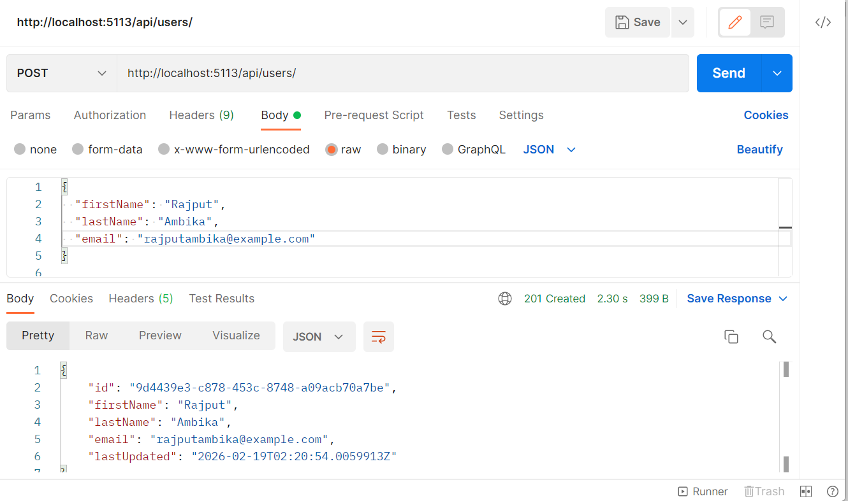

Get User by Id
GET /api/users/{id}
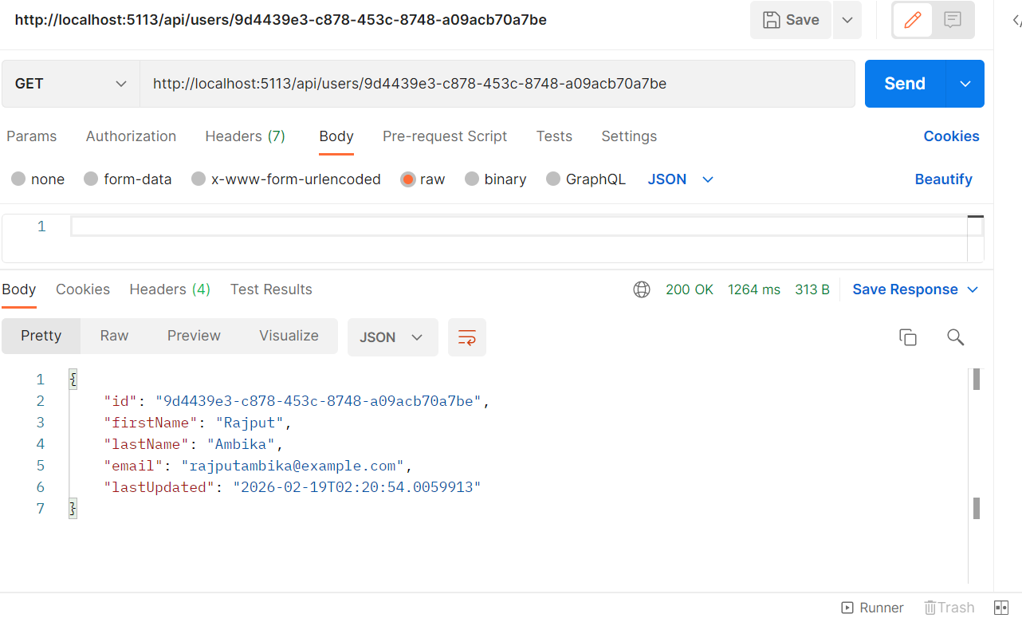

Update User
PUT /api/users/{id}
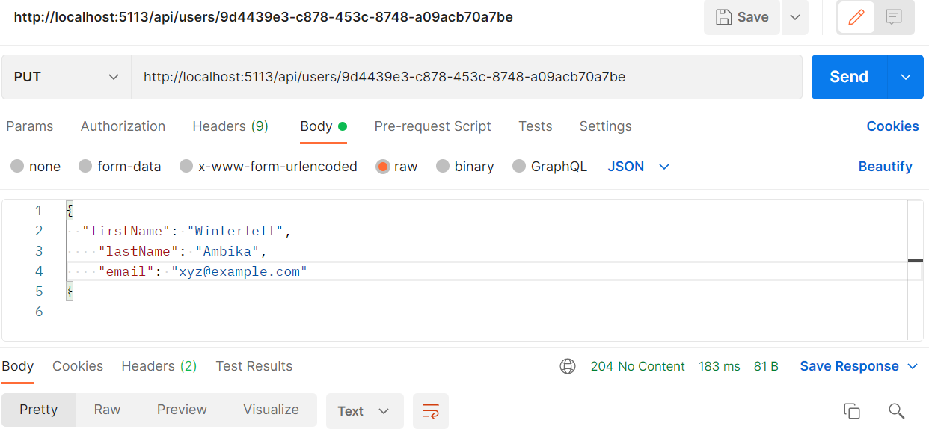

Testing Strategy
Manual Testing
- Postman used to validate:
  - Create user
  - Retrieve user
  - Update user
Unit Testing
- Service layer tested using xUnit
- Repository mocked using Moq
- Verified:
  - Creation logic
  - Update success
  - Update failure when user does not exist
All tests passed successfully.
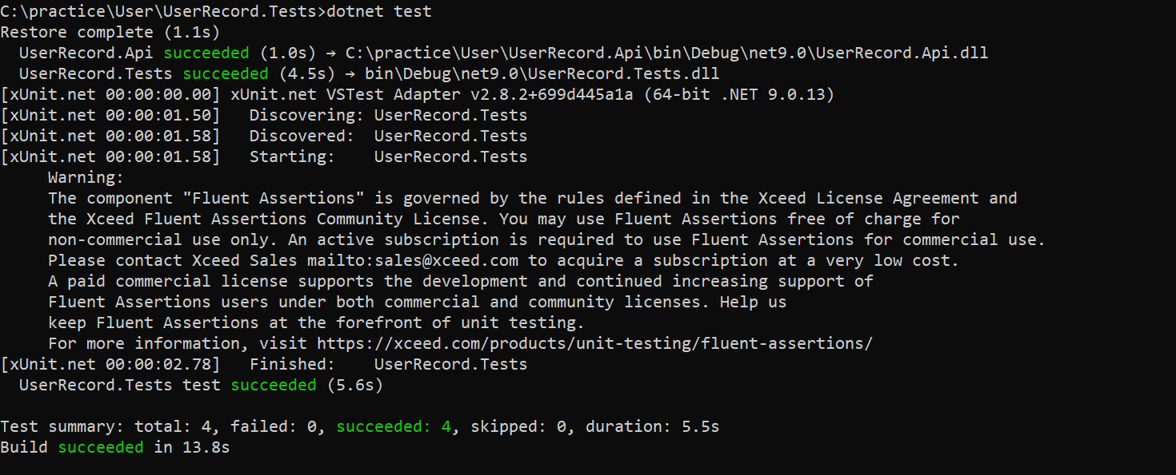

Development Notes and references
During development:
- W3Schools was referenced for quick syntax checks and C# structure reminders.
- ChatGPT was used as a debugging assistant to resolve:
  - NuGet package mismatches
  - EF Core setup issues
  - Migration configuration problems
All architecture, implementation, and testing decisions were designed and implemented independently, with external tools used strictly for troubleshooting and learning support.

Key Design Considerations
- Proper HTTP status codes
- Clear separation of layers
- Testability through dependency injection
- Simple and maintainable structure
- SQLite chosen for lightweight persistence

